The Theory of Short-Run Fluctuations (IS and LM Curve Analysis)
This schematic diagram shows how the different pieces of the theory of short-run fluctuations fit together. The Keynesian cross explains the IS curve, and the theory of liquidity preference explains the LM curve. The IS and LM curves together yield the IS–LM model, which explains the aggregate demand curve. The aggregate demand curve is part of the model of aggregate supply and aggregate demand, which economists use to explain short-run fluctuations in economic activity.
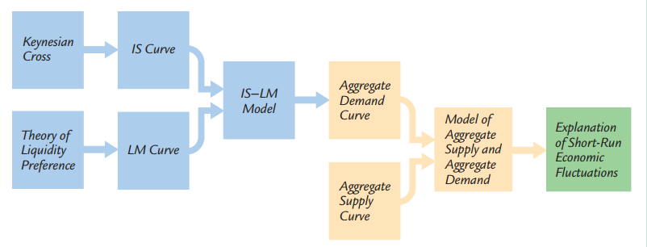
The goods market and the IS curve
The IS curve plots the relationship between the interest rate and the level of income that arises in the market for goods and services. To develop this relationship, we start with a basic model called the Keynesian cross.
Keynes proposed that an economy’s total income was, in the short run, determined largely by the desire to spend by households, firms, and the government. Planned expenditure is the amount households, firms, and the government would like to spend on goods and services. Assuming that the economy is closed, so that net exports are zero, we write planned expenditure E as the sum of consumption C, planned investment I, and government purchases G i.e.
E=C+I+G. To this equation, we add the consumption function C=C (Y−T). This equation states that consumption depends on disposable income (Y−T), which is total income Y minus taxes T. To keep things simple, for now we take planned investment as exogenously fixed. Combining these equations, we obtain E=C(Y−T) + I+ G. This equation shows that planned expenditure is a function of income Y, the level of planned investment I and the fiscal policy variables G and T.
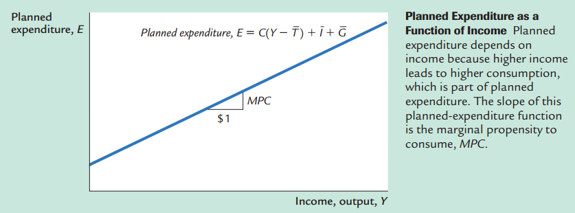
Recalling that Yas GDP equals not only total income but also total actual expenditure on goods and services, we can write this equilibrium condition as
Actual Expenditure =Planned Expenditure or Y=E.
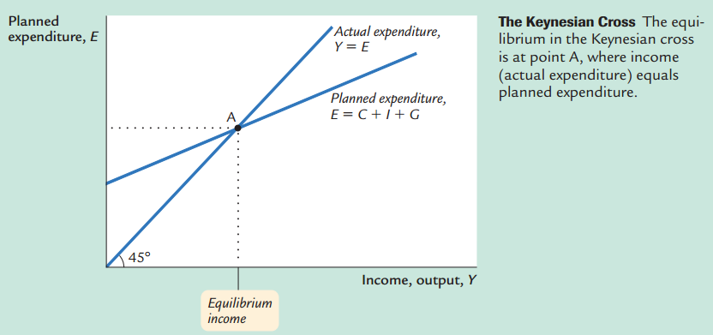

On the other hand, the LM curve plots the relationship between the interest rate and the level of income that arises in the market for money balances. To understand this relationship, we begin by looking at a theory of the interest rate, called the theory of liquidity preference. Keynes offered his view of how the interest rate is determined in the short run. That explanation is called the theory of liquidity preference, because it posits that the interest rate adjusts to balance the supply and demand for the economy’s most liquid asset—money.
If M stands for the supply of money and P stands for the price level, then M/P is the supply of real money balances. The theory of liquidity preference assumes there is a fixed supply of real money balances. That is
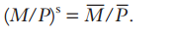
The money supply M is an exogenous policy variable chosen by a central bank, such as the Federal Reserve.
Next, consider the demand for real money balances. The theory of liquidity preference posits that the interest rate is one determinant of how much money people choose to hold. The reason is that the interest rate is the opportunity cost of holding money: it is what you forgo by holding some of your assets as money, which does not bear interest, instead of as interest-bearing bank deposits or bonds. When the interest rate rises, people want to hold less of their wealth in the form of money. We can write the demand for real money balances as (M/P)^{d}=L(r).
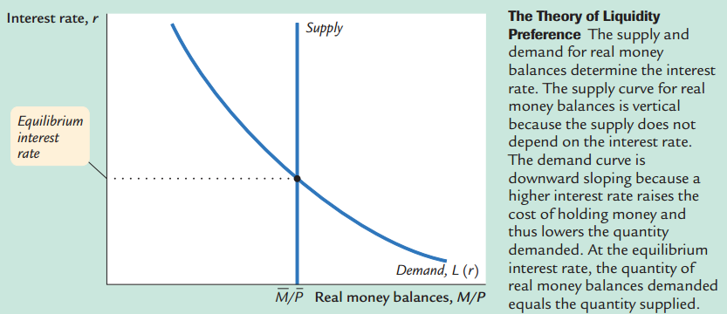

Now the Short-run equilibrium: The model takes fiscal policy, G and T, monetary policy M, and the price level P as exogenous. Given these exogenous variables, the IS curve provides the combinations of r and Y that satisfy the equation representing the goods market, and the LM curve provides the combinations of r and Y that satisfy the equation representing the money market.
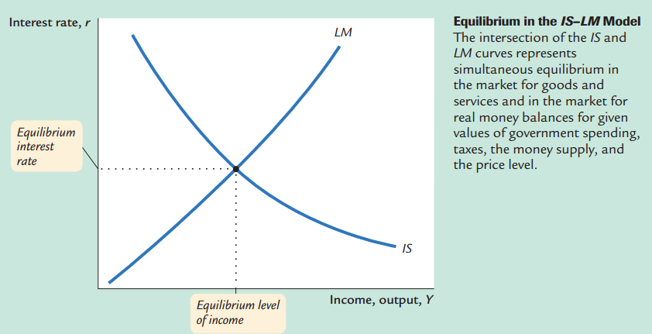

The equilibrium of the economy is the point at which the IS curve and the LM curve cross. This point gives the interest rate rand the level of income Y that satisfy conditions for equilibrium in both the goods market and the money market. In other words, at this intersection, actual expenditure equals planned expenditure, and the demand for real money balances equals the supply.

Source: Mankiw, Macroeconomics

